Unit 5.4 – Government Deficits, Debt and Crowding Out
- Which of the following is true about a country’s national debt?
- It is the sum of the country’s trade deficit and government budget deficit.
- It increases when gross domestic product increases.
- It increases when the country’s government has a budget deficit.
- It decreases when the country’s exports exceed its imports.
- It decreases when national savings decrease.
- When the total amount the government spends equals tax revenues in any given year, which of the following must remain constant?
- The real interest rate
- The national debt
- Real gross domestic product
- The price level
- The money supply
- In the short run, how would a government’s budget deficit, national debt, and real output change if government spending increases with no change in taxes?
Deficit Debt Real Output
- Increase Increase Decrease
- Increase Decrease Increase
- Increase Increase Increase
- Decrease Decrease Increase
- Decrrase Increase Decrease
- Suppose that in 2017 government outlays exceeded tax revenues. An increase in government purchases in 2018, with no other budgetary changes, would lead to which of the following from 2017 to 2018 ?
- An increase in the government budget surplus
- A decrease in the government budget surplus
- An increase in the government budget deficit
- A decrease in the government budget deficit
- A decrease in the national debt
- If the total of government spending plus government transfer payments is less than tax revenues, which of the following must be true?
- The national debt will increase.
- There is a recessionary gap.
- The government budget is in surplus.
- The velocity of money will increase.
- The money multiplier will increase.
- Country X has a budget deficit. Which of the following changes in government budget outlays and tax revenues will result in a decrease in Country X’s government budget deficit?
Gov Outlays/Expenditure Tax Revenues
- Fall by 100 Fall by 600
- Fall by 200 Fall by 200
- Rise by 300 Fall by 300
- Rise by 400 Rise by 600
- Rise by 500 Rise by 500

- Assume that the loanable funds market in Country X is currently in equilibrium.
- Draw a correctly labeled graph of the loanable funds market for Country X, and label the equilibrium interest rate as r* and the quantity of funds as QF*.
- Assume that the government of Country X, which had a balanced budget, now increases its spending while holding taxes constant. Assume that the government funds the increase in spending with increased borrowing.
- What will be the impact of this policy action on the government’s budget balance?
- On your graph in part (a), show the impact of this policy action on the interest rate and quantity of funds.

Answers:
1 | C
2 | B
3 | C
4 | C
5 | C
6 | D

- Given your answer in part (b) (ii), how will private-sector interest-sensitive expenditures be affected?
- Given your answer in part (c), what will be the impact on the long-run growth rate of the economy? Explain.

- Assume that the current unemployment rate in Country A is higher than the natural rate of unemployment.
(a) Draw a single correctly labeled graph with both the long-run Phillips curve and the short-run Phillips curve.
Label the current short-run equilibrium point Z.
(b) Identify a specific fiscal policy action that would bring the economy to full employment.
(c) Draw a correctly labeled graph of the loanable funds market, and show the effect of the fiscal policy from part (b) on the real interest rate in the short run.
(d) Now assume instead that there is no fiscal policy action. Will the short-run Phillips curve shift to the right, shift to the left, or remain the same over time? Explain.

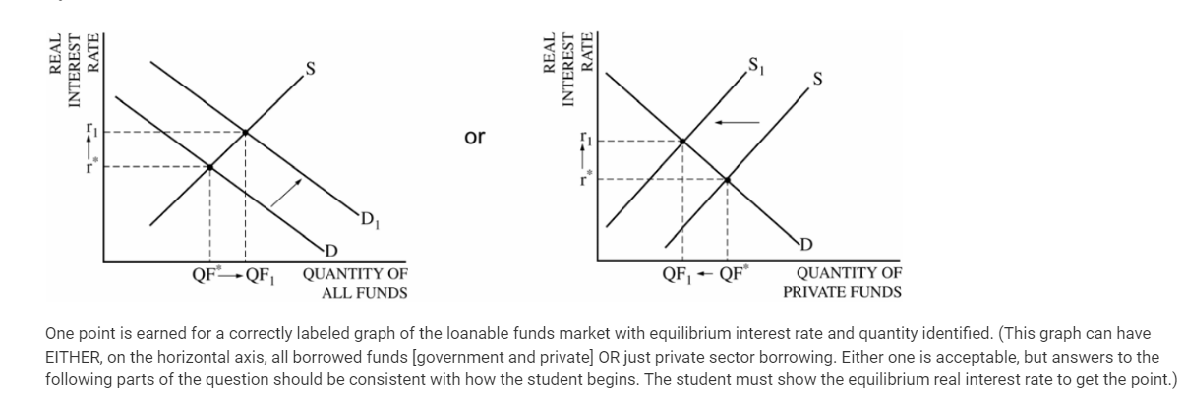
b
Budget deficit
Rightward shift of the demand curve OR leftward shift of supply curve → higher interest rate
c Higher interest rate will reduce consumption and private investment spending
d growth rate will decrease or economy will grow at a reduced rate because of less capital formation which would have lead to economic growth (increase in the factors of production)

8
There would actually be the opposite of crowding out, because there would be less government borrowing, leading to an increase in the amount of private investment.

